CQRS and Event Sourcing using Axon Framework

Two microservices patterns **CQRS** and the **Event Sourcing** patterns, are coming from the **Domain Driven Design** planet. In the most of the use-cases, these two patterns are sold together.

In this new tutorial, we will discover what does each one? why they are usually used together? and for sure **we will implement these two patterns in Java** obviously.

# What is CQRS pattern?

**CQRS** stands for **Command Query Responsibility Segregation** is a design pattern that aims to **separate** the **Read**and**Write**operations. In the CQRS distinguishes the operations as:

* **Queries**: A Read only operation – no state is updated after executing queries
* **Commands**: A Writing operation – state is updated after executing commands

In **CQRS**, we segregate the responsibility of Command i.e., create, update and delete with Query.

**CQRS** separates the responsibilities, typically into different components. The first component covers **CUD operations** (without the Reading), while a second component will ensure the **Read** **operation**.

The schema describes the CQRS pattern:

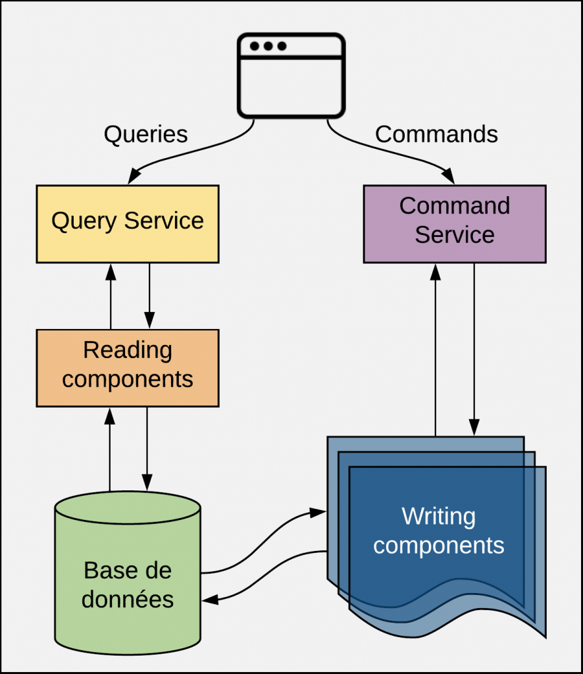

*CQRS pattern*

A **Query** is a **Read operation**, that **does not update any the state** of the application. A **Query** is handled by the **Reading Components** that will interact with the **DB**, parses the **DB response**, creates a **Data Transfer Object** that will be returned to the User.

A **Command** is a **Business Action** that the Application’s user want to do, for example: *RegisterStudent*, *MakeDeposit*, etc..

Every **Command** has a **Handling Layer** that knows how to apply the **Business Action**. Generally, commands are inserted in a **Queue** to be processed **asynchronously**, so technically speaking, a **Command Handler** is invoked by a **Queue Listener**.

# What is event sourcing pattern?

Event Sourcing persists the state of a business entity (**BankAccount** for example) as a sequence of state-changing events in event store. Every action performed on a business entity should be persisted. The application reconstructs an entity’s current state by replaying the events.

For example, to reconstruct a given **BankAccount** current state, we need to replay all the events occurred on this business entity. It means we do not store the state of the **BankAccount**.

Applications persist events in a database of events called **event store**. The store has an API for adding and retrieving an entity’s events. The **event store** also behaves like a message broker. It provides an API that enables services to subscribe to events. When a service saves an event in the event store, it is delivered to all interested subscribers.

Some entities, such as a **BankAccount**, can have a large number of events. In order to optimize loading, an application can periodically save a **snapshot** of an entity’s current state. To reconstruct the current state, the application finds the most recent **snapshot** and the events that have occurred since that **snapshot**. As a result, there are fewer events to replay.

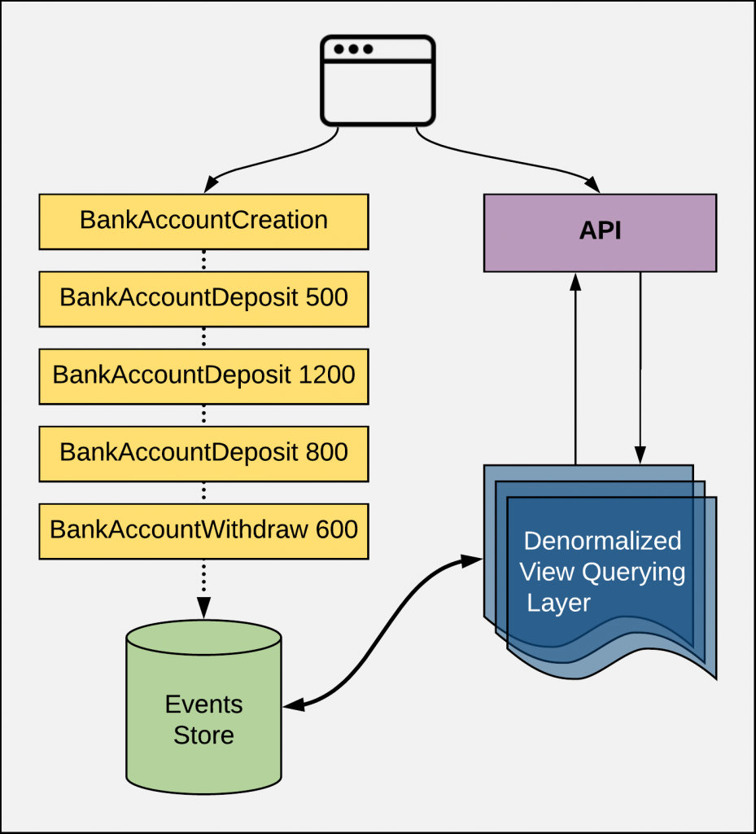

*Event Sourcing (very) simplified diagram*

# Why we are always coupling these patterns?

**CQRS** separates the responsibilities, typically into different components. The first component covers **CUD operations** (without the Reading), while a second component will ensure the **Read** **operation**.

**Reads** and **writes** from different places can create a timing issue. Most database theory focuses on consistency. It should be possible to keep a log of every data change. That way, at any point in time, the values that the queries display are logically correct. Here comes the **Event Sourcing**, which will ensure consistency.

**Event Sourcing** stores a record of every action in a dedicated database. From there, an **event handler** reads these changes in order, applies them appropriately and marks them as complete once the transaction is complete. This **event handler** does not need to be complex — it can be as simple as an *API endpoint*. Once the **event handler** creates an event record, a central service messaging system can push notifications every time it discovers about a new event.

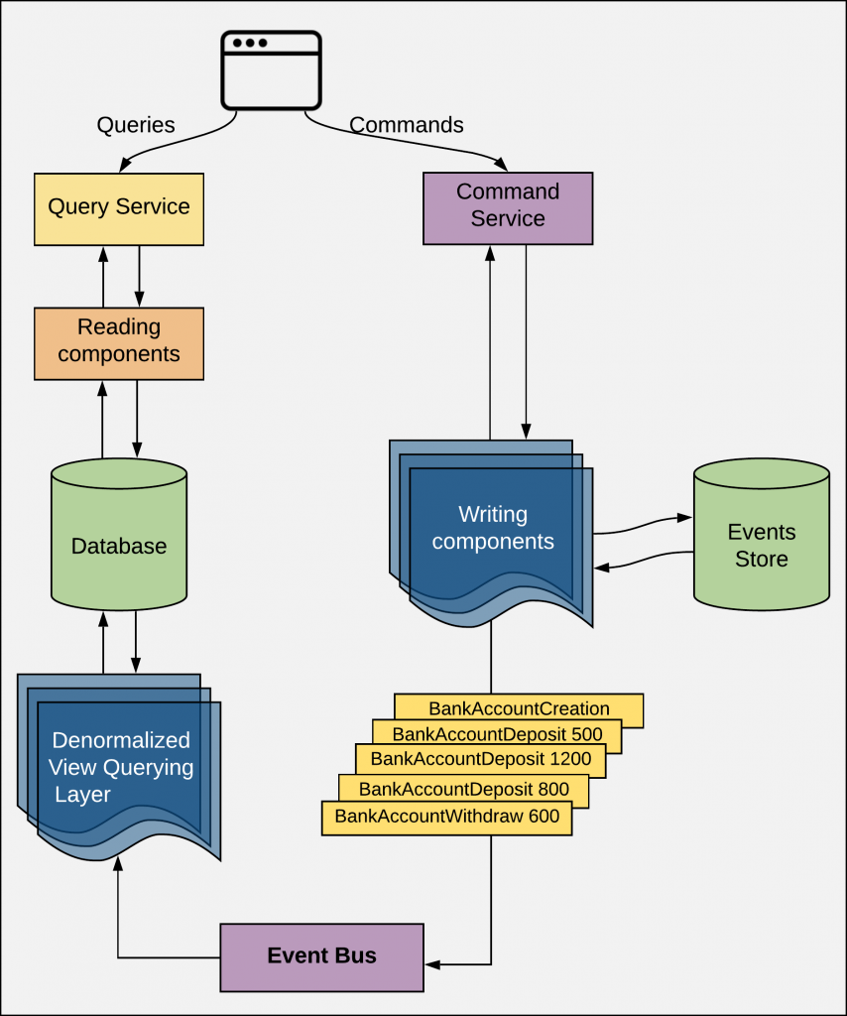

*Coupling CQRS and Event Sourcing Diagram*

**CQRS** and **Event Sourcing** patterns are frequently used together. Coupling these two patterns means that each event on the **Writing** part of our application. Obviously, the Reading part is made by playing the events.

# Implement the CQRS & Event sourcing using AXON framework

We will create a small **Spring Boot application** on which we will implement **CQRS**and**Event Sourcing patterns** using **Axon**.

## What is Axon?

Axon Framework is **a Java framework that** provides a clean, **elegant Java API for writing DDD, CQRS and Event Sourcing applications**. This framework helps in developing event driven microservices.

It provides implementations of the most important basic building blocks for writing aggregates, commands, queries, events, sagas, command handlers, event handlers, query handlers, repositories, communication buses and so on to help developers apply the CQRS architectural pattern when building applications.

Axon consists of the following:

* Axon Framework – to build the application
* Axon Server – to run the CQRS and Event source-based application

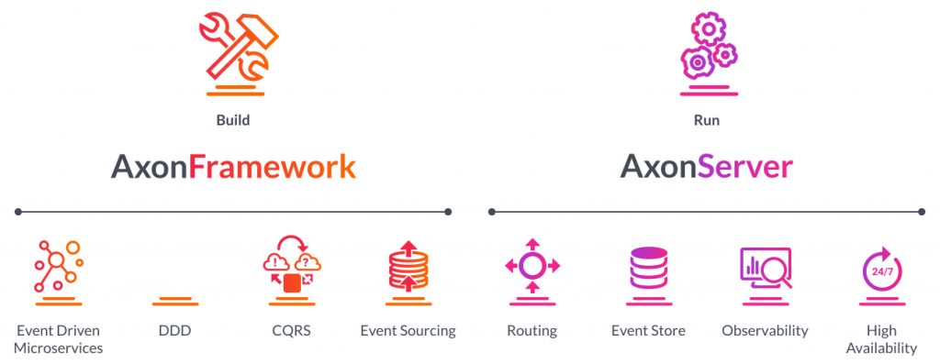

*Axon Framework and Server – Official documentation*

## Initialize the application with dependecies

Let’s dig into the coding part; we will start by generating the **Spring Boot application** using the **Spring Initializer** with these dependencies:

* Web
* H2
* Actuator
* H2 Database
* Lombok

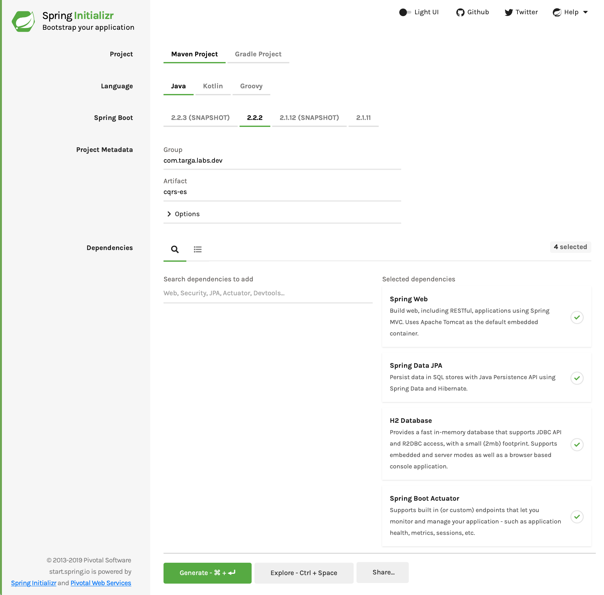

*Generating the Spring Boot application*

After generating the project. We will add these dependencies to the pom.xml:

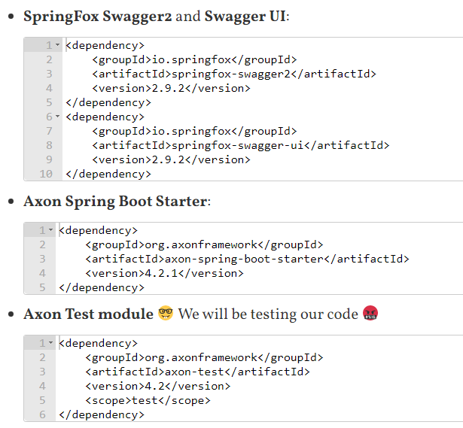

Our **sample application** will be a **Bank Account** manager. Our **application** will have these features:

* Create a new account for a given **Owner** with a given **Initial Balance**
* Credit an amount on a given account
* Debit an amount from a given account
* Read information about a given account

A **BankAccount** will look like:

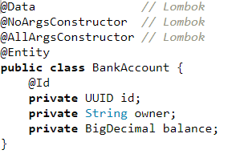

## Commands and queries

Now, we need to list the **Reading** and **Writing** actions related to the application features:

|  |  |  |
| --- | --- | --- |
| **Feature** | **Command** | **Query** |
| Create a new account | Yes | No |
| Credit an amount from account | Yes | No |
| Debit an amount from account | Yes | No |
| Get Account information | No | Yes |

Based on this table, our commands will be:

* CreateAccountCommand
* CreditMoneyCommand
* DebitMoneyCommand

For the queries, we will have only one:

* FindAccountQuery

– What’s next ?

– Did you forgot that the **CQRS and Event Sourcing** are two patterns that belong to the **DDD paradigm**? As it’s a **Domain Driven**, we need to start designing our **Domain**

We will start by implementing the**Command model** for our **CQRS segments**, using **Aggregates**

## Command Part: Aggregate and Command Handler

**Aggregate** is a pattern in **Domain-Driven Design**, and in this level (the design) we don’t talk about technical details.  This is why I would like to say **business entity** instead **entity**.

The updated definition that I like

* An **Aggregate**is a regular object, which contains state and methods to alter that state.
* An **Aggregate** is a business entity or group of business entities that is always kept in a consistent state (within a single ACID transaction). The **Aggregate Root** is the business entity within the **aggregate** that is responsible for maintaining this consistent state.

For example: an **aggregate** can be an e-Commerce **Order** with the related **OrderItems** and **Customer** information. Here, the **Order** class is the **Aggregate Root**:

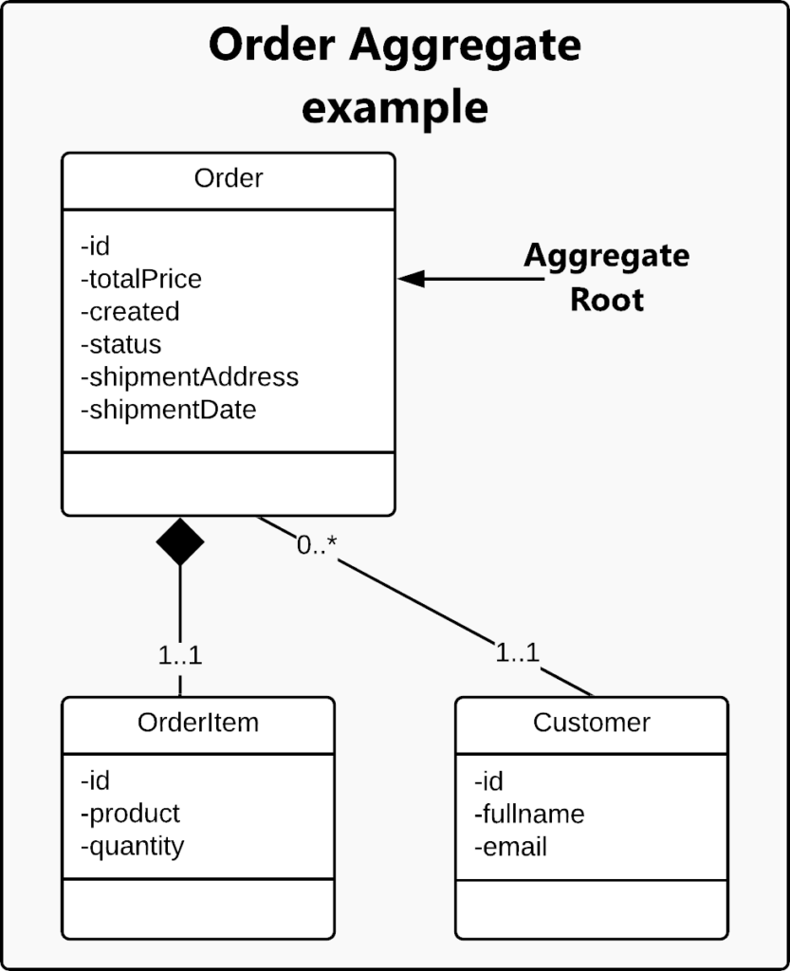

*Order Aggregate example*

In our application, our **Aggregate** is the **BankAccountAggregate** will look like:

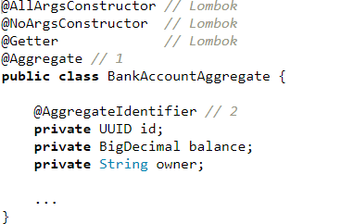

1. The @Aggregate annotation informs **Axon’s auto configure for Spring** that this class is an **Aggregate** instance.
2. The @AggregateIdentifier identifies the field as the identifier of the **Aggregate**.

For sure that you are saying now that the BookAccountAggregate and the BookAccount *JPA Entity* looks like the same structure. Why are we duplicating the code? Why don’t we use the BookAccountAggregate class as the *JPA Entity* class? The answer is that the BookAccountAggregate will contain more Axon boilerplate code which cannot fit to a *JPA Entity* class, which is used only to represent data stored in a DB.

Let’s continue to code our **BookAccountAggregate** class.

Now we will code the constructor. We already said that we have a **Command** that will create a new account: **CreateAccountCommand**. Here will come the first glue between the **Commands** and the **Aggregate**: The **CreateAccountCommand** will be passed to the **Aggregate** constructor:



The @CommandHandler will mark this method (constructor) as a **Handler** of the **CreateAccountCommand**. The command needs to bring the data needed by to construct the **BankAccount** instance. Think of it as a **Data Transfer Object** used to wrap data received and sent via REST APIs. Obviously a **CreateAccountCommand** will have the same content like the **BankAccount**JPA Entity and the **BookAccountAggregate**. It will look like:

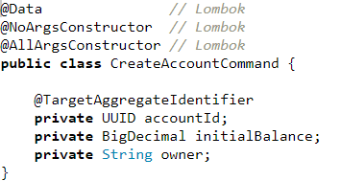

The @TargetAggregateIdentifier will identify the field as the identifier of the targeted **aggregate**.

We said before that in the **CQRS** and **Event Sourcing** based applications, for every **Command** made, we dispatch an **Event**.

For example; for the **CreateAccountCommand** we need to create an **AccountCreatedEvent** that will be used to say that a **Command** has been received.



Guess what the **AccountCreatedEvent** will look like:

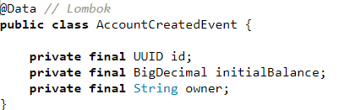

Now, the **CommandHandler** will look like:

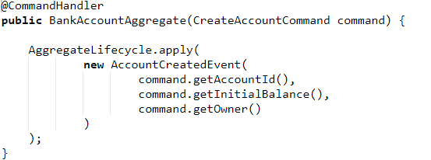

The AggregateLifecycle component is used to notify the **Aggregate** that a new **BankAccount** was created by publishing the **AccountCreatedEvent**.

Good! The same way, if we dispatched a **Command**, we defined its **CommandHandler**. Now, as we dispatched an **Event**, we need to define the **EventHandler**:

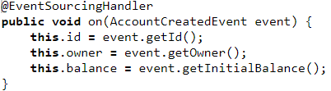

EventSourcingHandler is on the command side’s Aggregate to dictate how the Aggregate will change, given that event. The @EventSourcingHandler will define the annotated method as a handler for **Events** generated by that **Aggregate.**

Now, we will define the two remaining **Commands:**

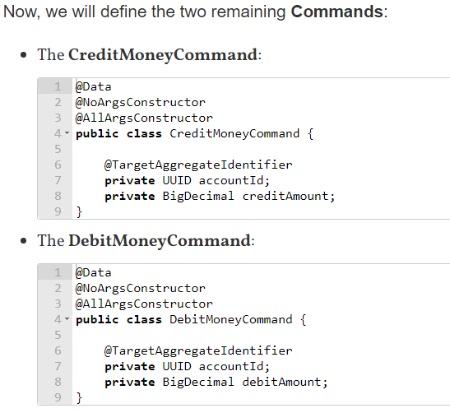

The remaining two **Events**:

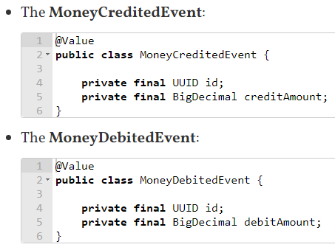

The **BankAccountAggregate** will finally look like:

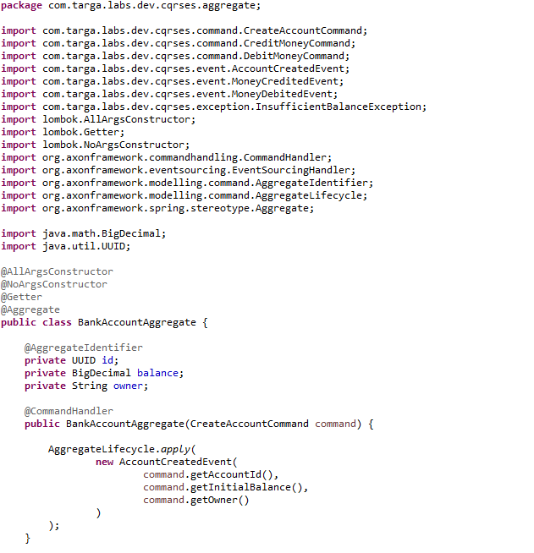

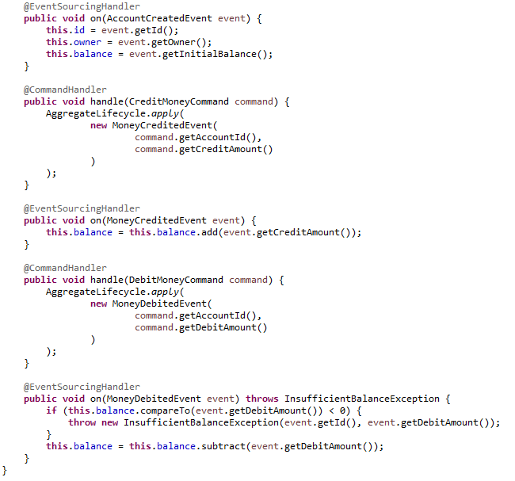

I defined an InsufficientBalanceException for handling an error while debiting money:

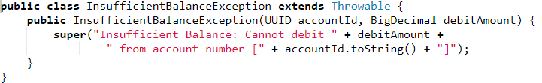

At this stage, we created the **aggregate** that receives and handles the **Commands** and for every **Command** will dispatch a **Query**.

Good! But no data is inserted in the DB, no boundary is available to emit instructions.

Now we will create the *JPA Repository* for our **BankAccount** *JPA Entity*:



Now, we can use the **BankAccountRepository** to made CRUD operations on **BankAccount** in the DB. Ok, but from where?

You can think in the **BookAccountAggregate**, but it will not be suitable, as it will be doing many tasks which will cause us to lose the ***Single Responsibility principle***.

The common practice is to create a dedicated class that will match the DB operations for every received event. I saw that the **Axon team is calling it Projector class**.

We will call our **Projector** class **BankAccountProjection**that looks like:

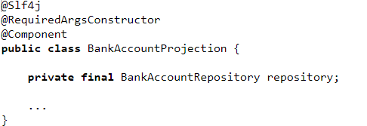

The **BankAccountProjection**is a **Spring Component** on which we injected our **BankAccountRepository**.

Good! Now, we need to define the **Handler** for every emitted **Event**. The **Event** is serving as a **DTO** wrapping the needed values to create a **BankAccount**

**EventHandlers** are normally on query applications/side to dictate what to do once an event has occurred. For example, the **EventHandler** for **AccountCreatedEvent,** **MoneyCreditedEvent** and **MoneyDebitedEvent**will look like:

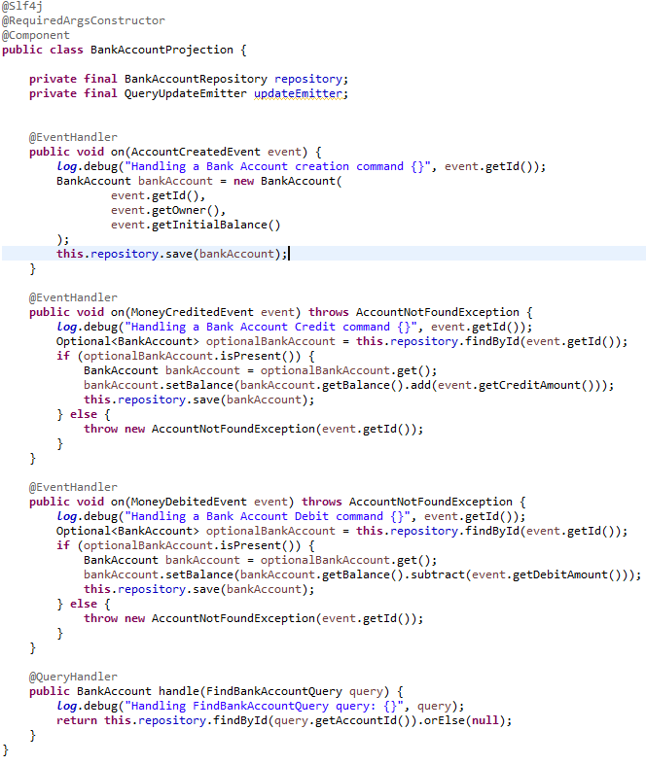

Here, I defined an **AccountNotFoundException** thrown when no account is found:

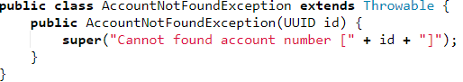

Yoopi!  Now, we will need the REST API and the **Spring Service** that will be receiving the **HTTP Requests** and dispatching the **Commands** to the **Axon Engine**.

Let’s start by the **REST API** for the **Commands**:

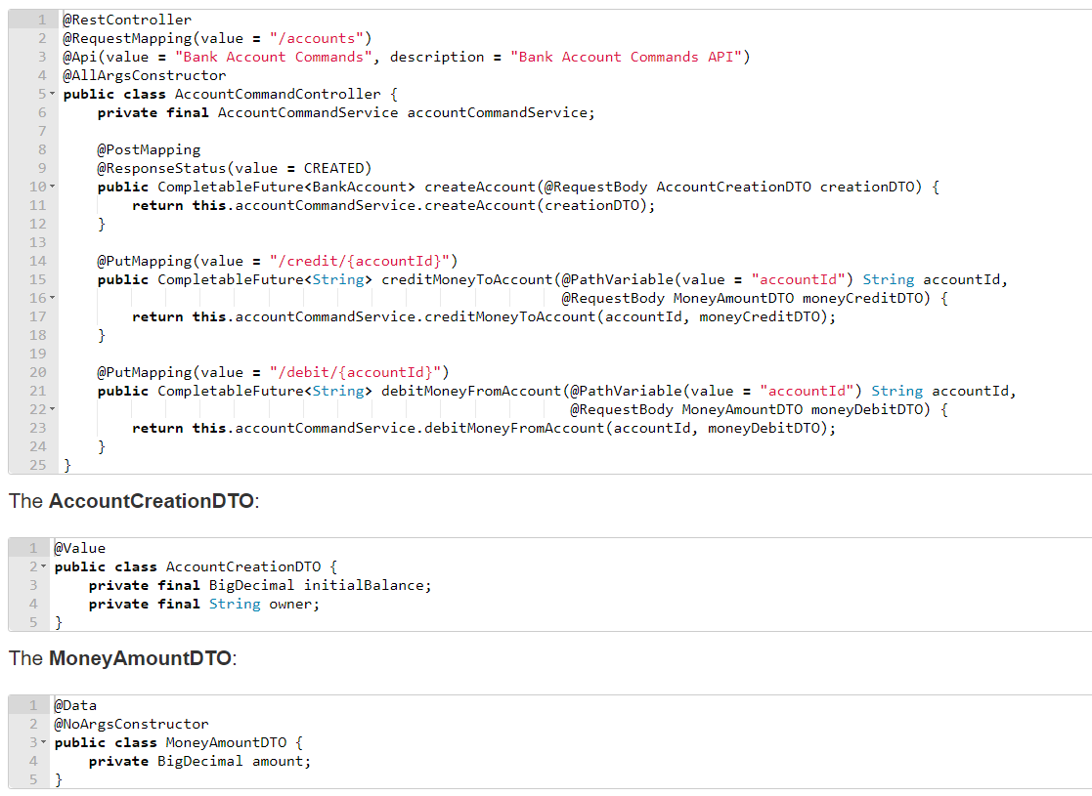

Now, we will create the **Spring Service** that will be dispatching the **Commands** to the **Axon Engine**. To do this, the framework has a very useful component called **CommandGateway**, which is a very convenient interface towards the command dispatching mechanism.

CommandGateway interface providing the functionality to dispatch command messages to Axon Engine. It does so by internally leveraging the CommandBus interface [dispatch messages](/reference-guide/v/4.0/implementing-domain-logic/command-handling/dispatching-commands#the-command-bus).

Our **AccountCommandService** will look like:

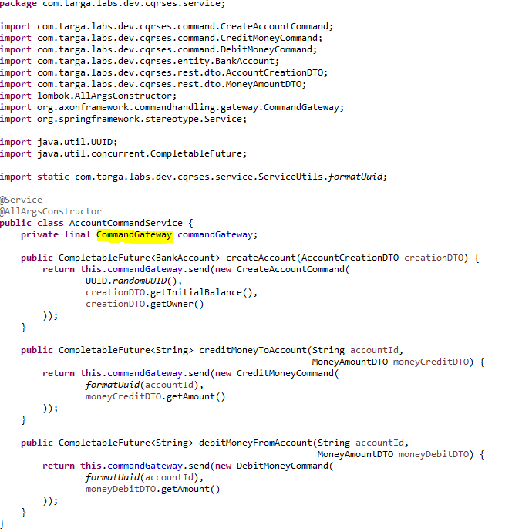

The send API as shown above introduces a couple of concepts, marked with numbered comments:

* The CommandGateway interface providing the functionality to dispatch command messages. It does so by internally leveraging the CommandBus interface [dispatch messages](/reference-guide/v/4.0/implementing-domain-logic/command-handling/dispatching-commands#the-command-bus).
* The aggregate identifier is, per best practice, initialized as the String of a random unique identifier. Typed identifier objects are also possible, as long as the object implements a sensible toString() function.
* The send(Object) function requires a single parameter, the command object. This is an asynchronous approach to dispatching commands. As such the response of the send method is a CompletableFuture.

This allows for chaining of follow up operations after the command [result](/reference-guide/v/4.0/implementing-domain-logic/command-handling/dispatching-commands#command-dispatching-results) has been returned.

**Callback when using send(Object)**

The CommandGateway#send(Object) method uses the FutureCallback under the hood to unblock the command dispatching thread from the command handling thread.

## Query Part

Cool! We need to define the **Query** part. Let’s start by defining **FindAccountQuery**:

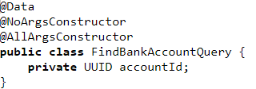

In the **BankAccountProjection**, we need to add a **QueryHandler** method:

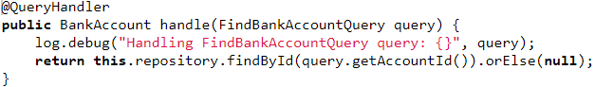

We need to create the **Query REST API** and **Service**. The **AccountQueryController** looks like:

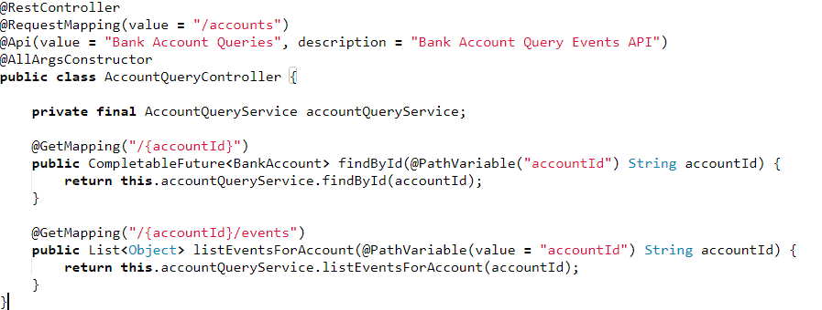

The **AccountQueryService** looks like:

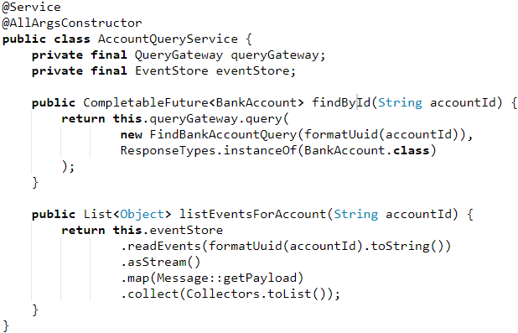

What is this strange **EventStore**?

**EventStore** provides access to both the global event stream comprised of all domain and application events. We will be using it to list all the events about a given **aggregate**.

We need to add these properties to the application.properties:

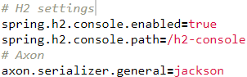

We will be using Swagger to have a small UI to test our REST APIs. The **SwaggerConfiguration** file looks like:

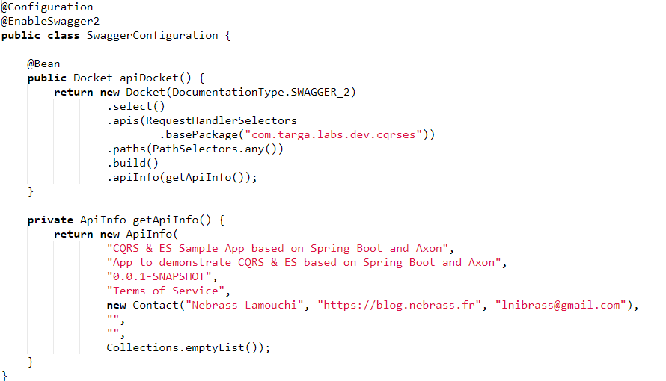

## Start our application

## Run the axon server as a docker



## Run the application

**mvn spring-boot:run**

Now, the **Axon Server UI** will be reachable on <http://localhost:8024/>

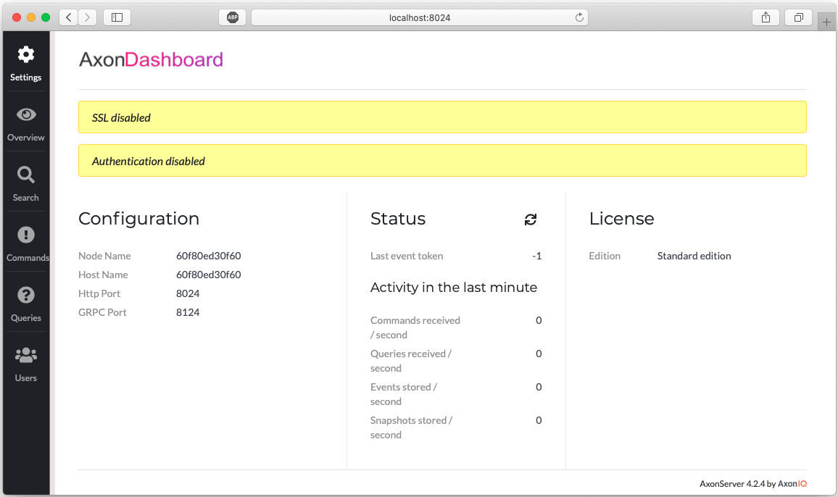

*Axon Server UI*

**If you click on the Overview section:**

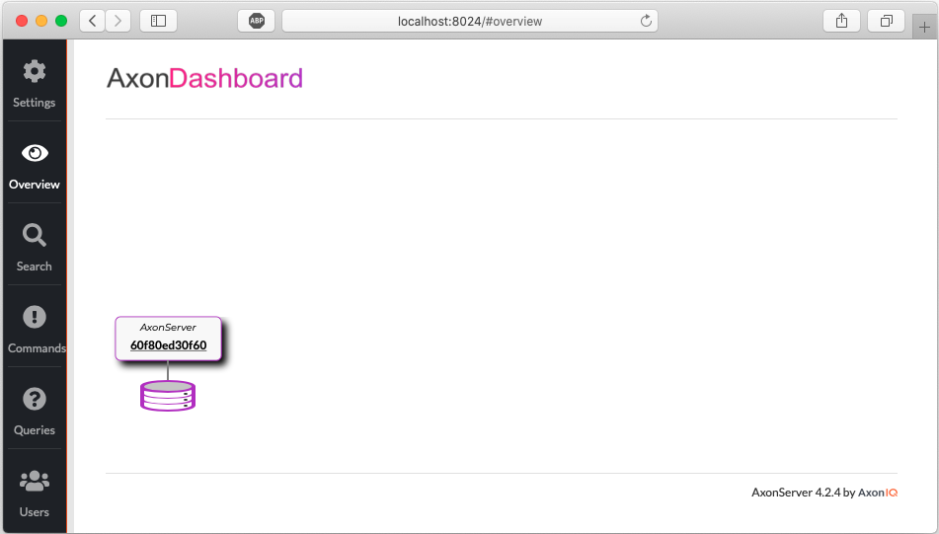

*Axon Server UI – Overview*

Next, check the **Commands** section:

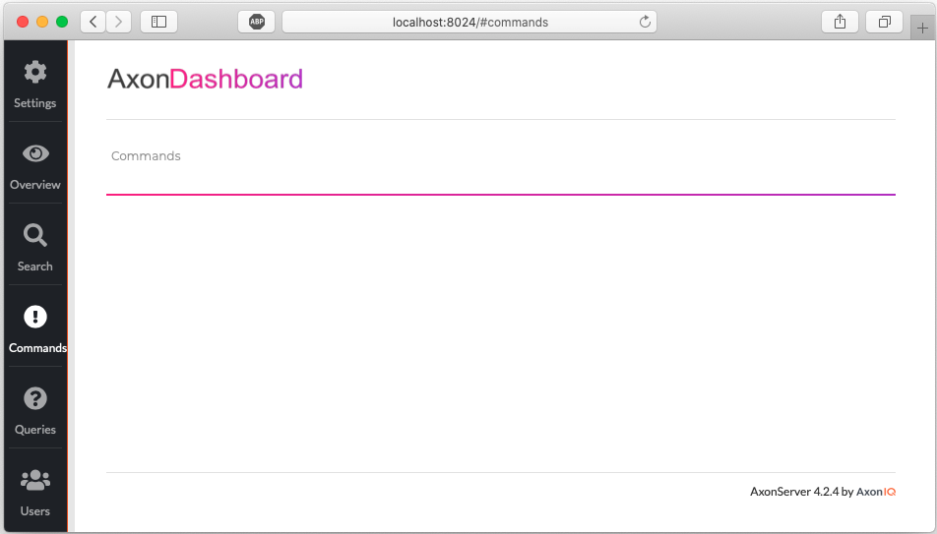

*Axon Server UI – Commands*

Next, check the **Queries** section:

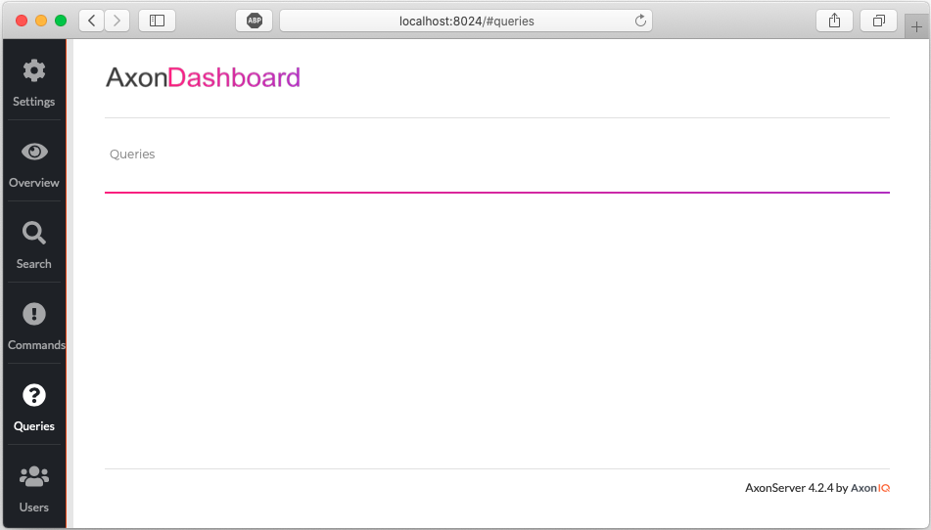

*Axon Server UI – Queries*

Nothing wrong. Don’t be scared, as no application is communicating with the **Axon Server**, everything is empty.

Let’s start now the application again:

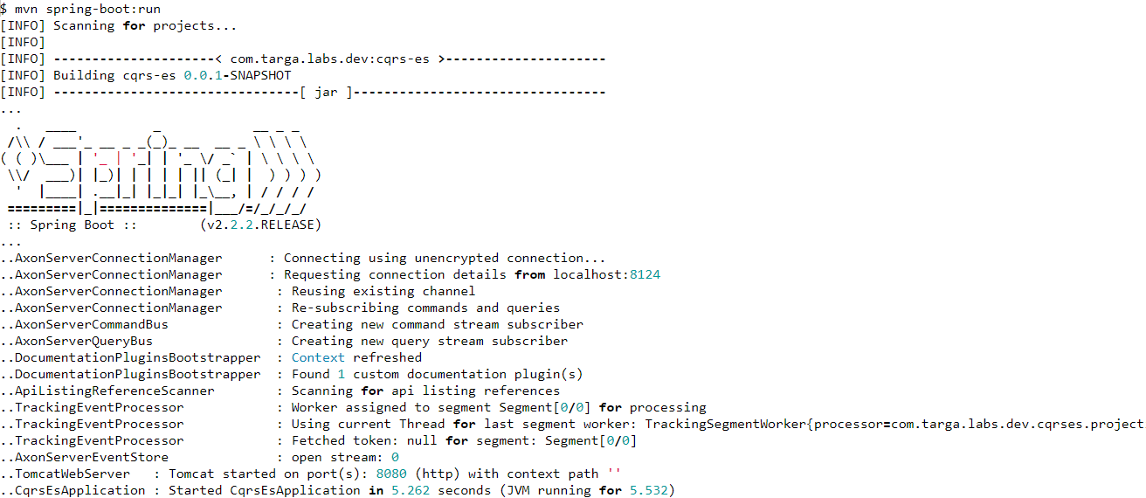

Cool ! Let’s access now the **Swagger UI** on <http://localhost:8080/swagger-ui.html>:

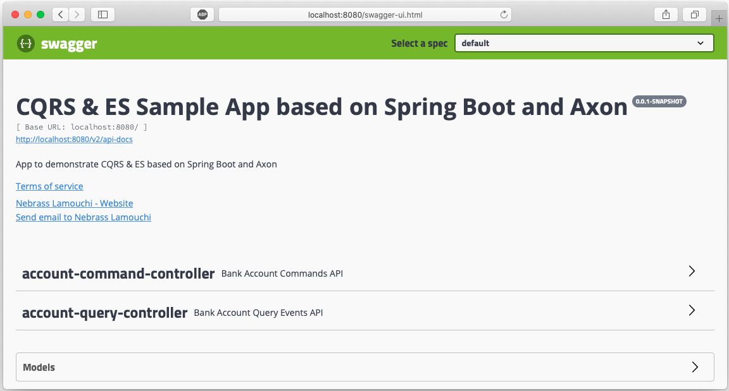

*Swagger UI*

As you see, there is already two **REST Controllers** one for the **Commands** and one for the **Queries**. Let’s test the **createAccount REST API**:

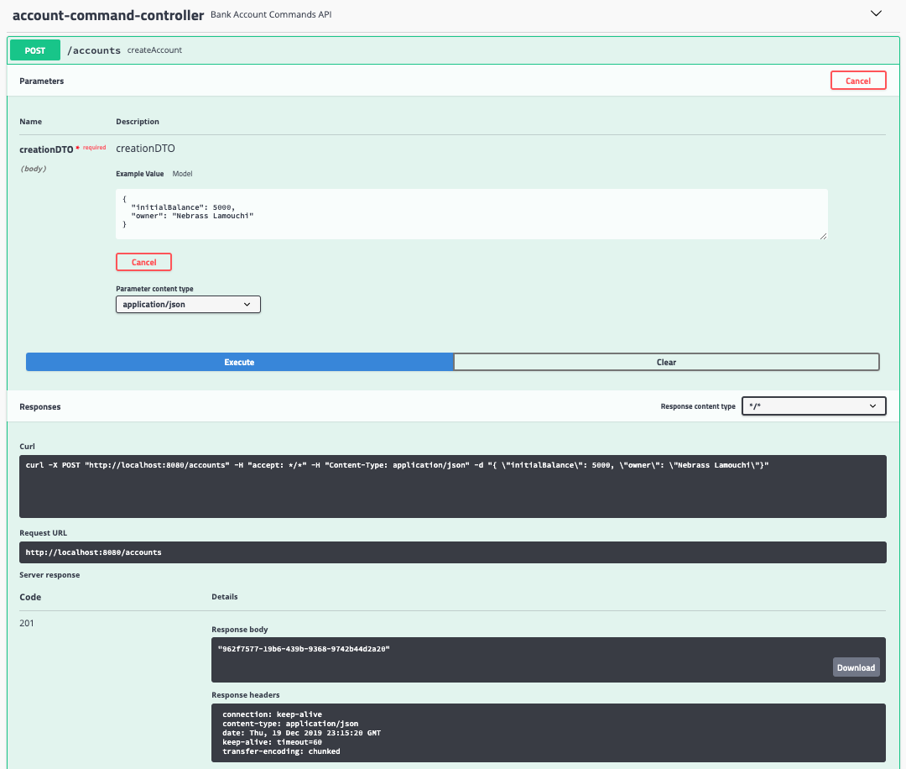

*Create Account – Swagger UI*

Here we created a new **BankAccount** that has:

* **id:** 962f7577-19b6-439b-9368-9742b44d2a20
* **initialBalance:** 5000
* **owner:** Nebrass Lamouchi

Next, I will test some **creditMoneyToAccount** operation **twice** the first with an amount of **300** and the second with **480**:

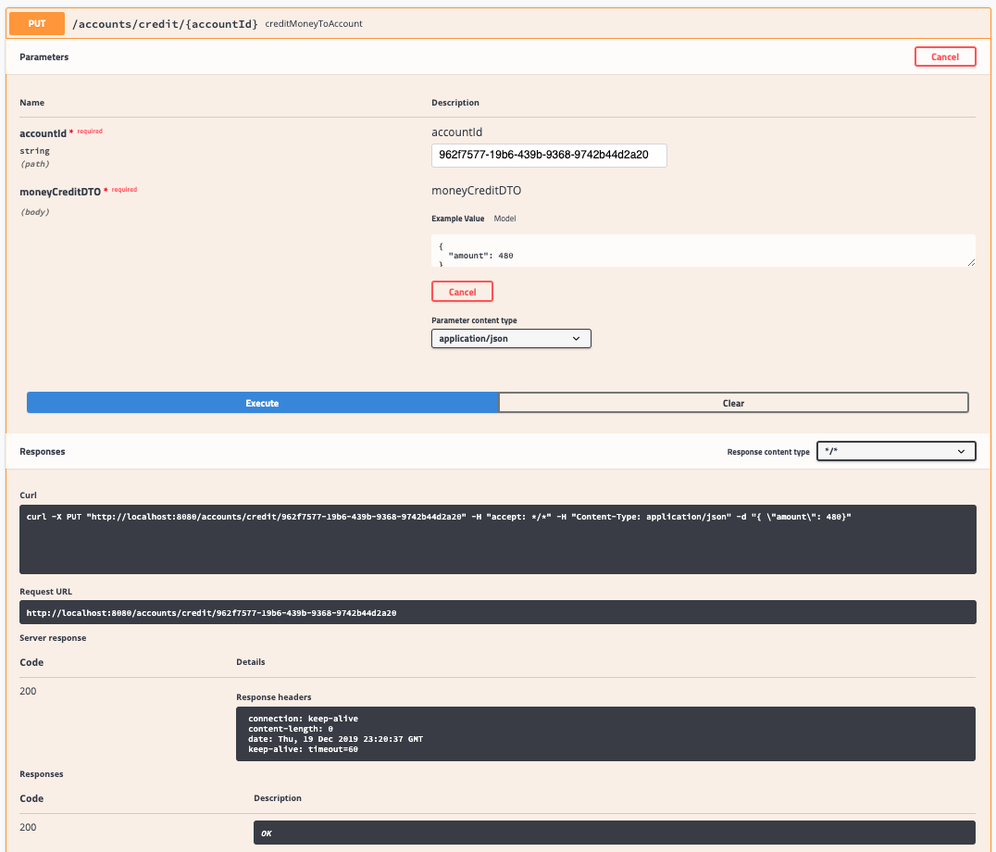

*Credit Account – Swagger UI*

Let’s **debit** the amount of **2000** from the sample account using the **debitMoneyFromAccount** operation:

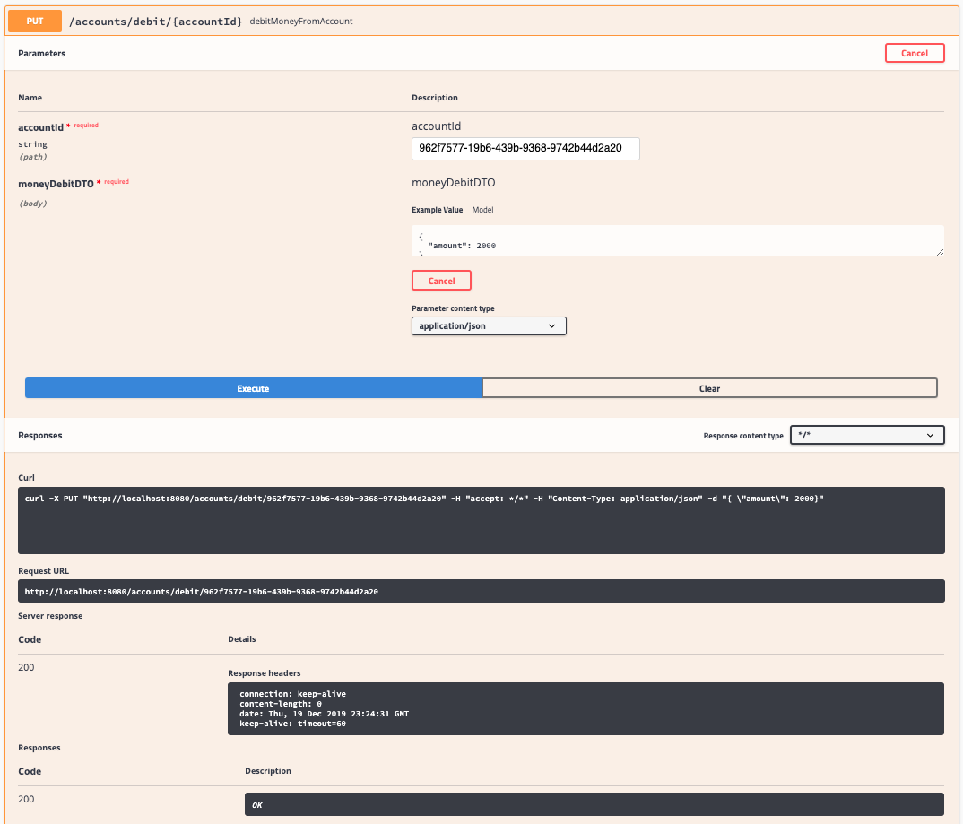

*Debit Account – Swagger UI*

Now, we need to check how much we have in our account, normally the remaining balance will be **5000 + 300 + 480-2000 = 3780**.

Let’s check the account using the **findById** operation on the **AccountQueryController**:

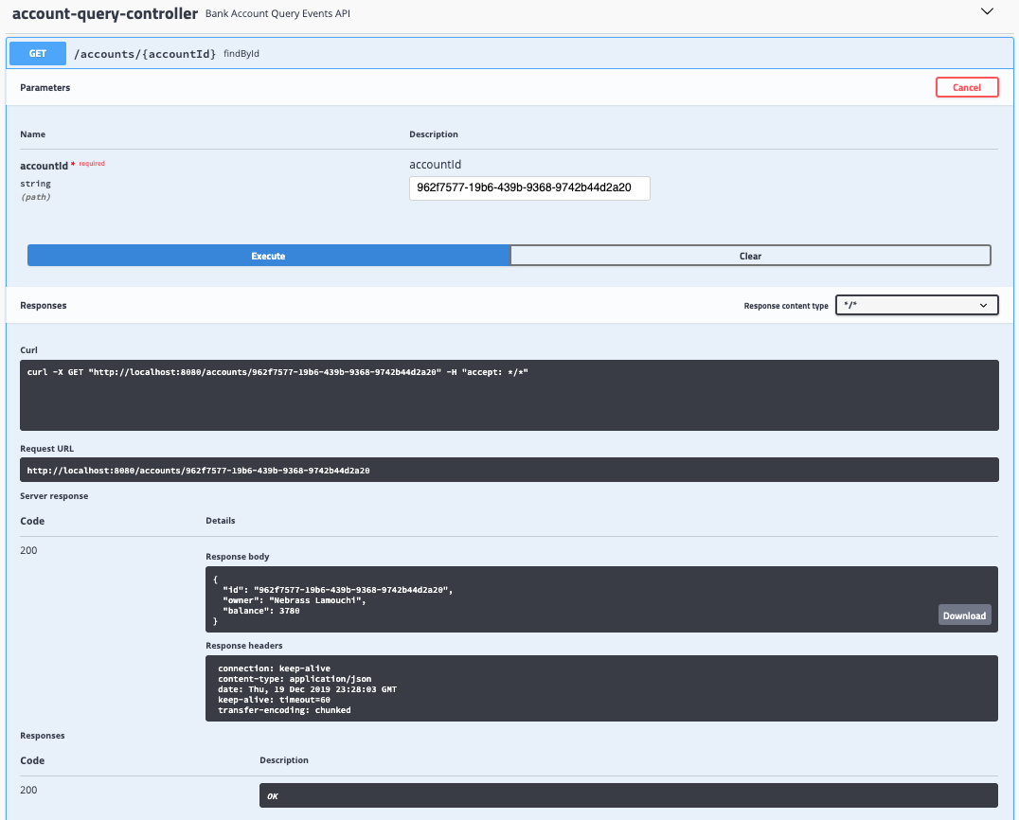

*Find Account by ID – Swagger UI*

As expected! **the balance is 3780**

We can verify the Events list occurred on our **BankAccount**using the **listEventsForAccount** operation:

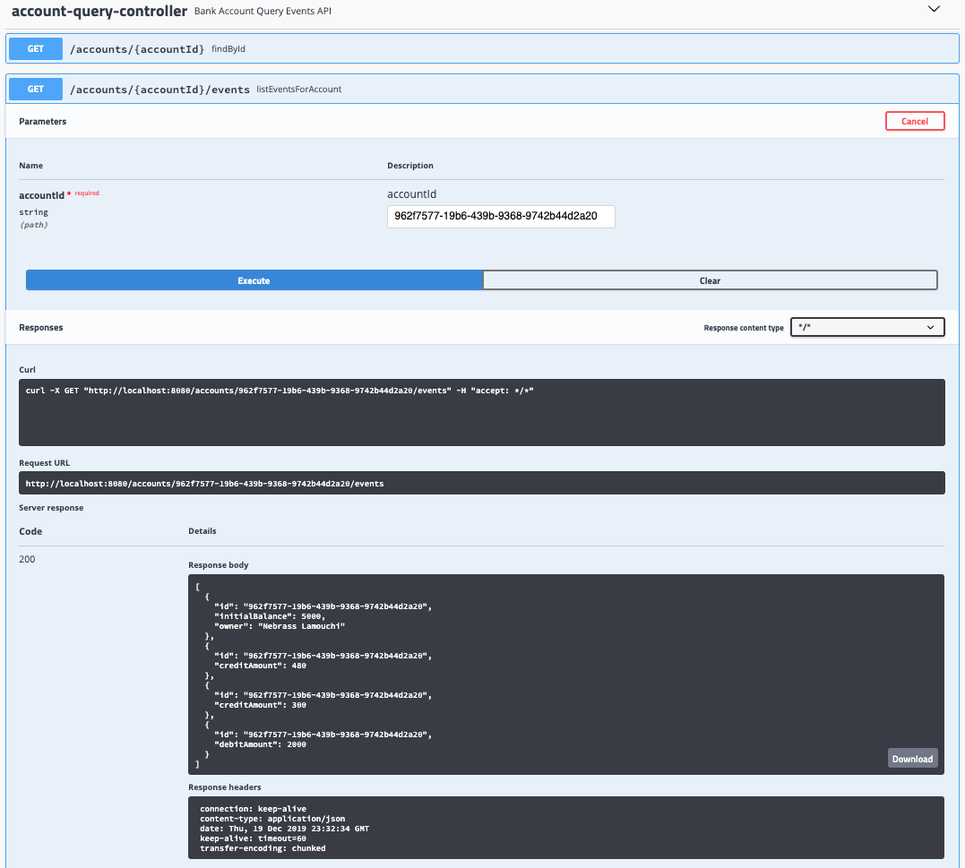

*Account Events list – Swagger UI*

Great! Everything is working like a charm!

After we executed our application and after we did some operations, let’s visit again the **Axon Server UI**:

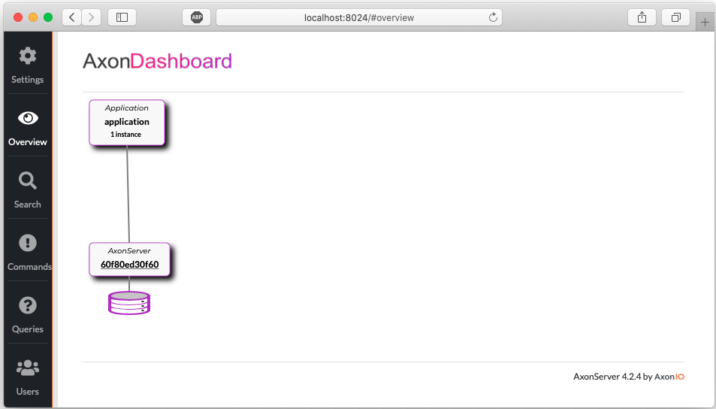

*Axon Server UI – Overview after execution*

As you see, our application instance is spotted on the **Axon Dashboard**. Let’s move to the **Commands** section:

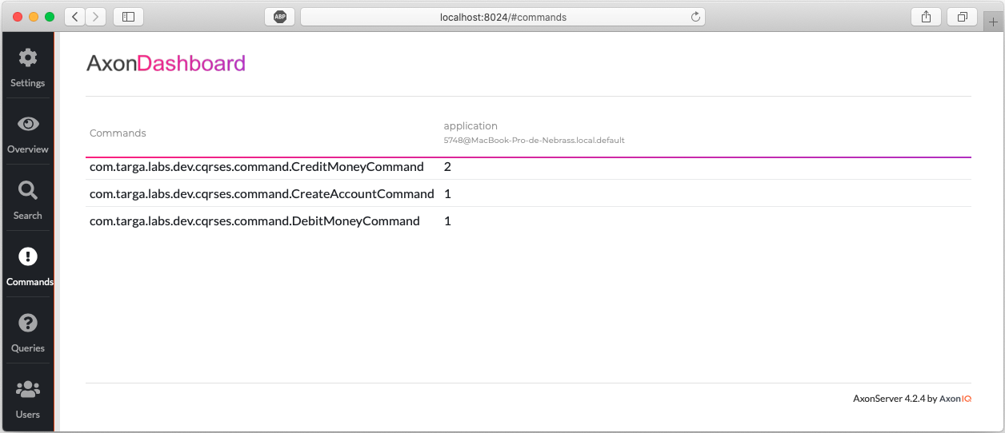

*Axon Server UI – Commands after execution*

You already see that the **CreateAccountCommand** was fired once, the **CreditMoneyCommand** twice (300 & 480) and the **DebitMoneyCommand** once (2000).

Next, move to the **Queries** section:

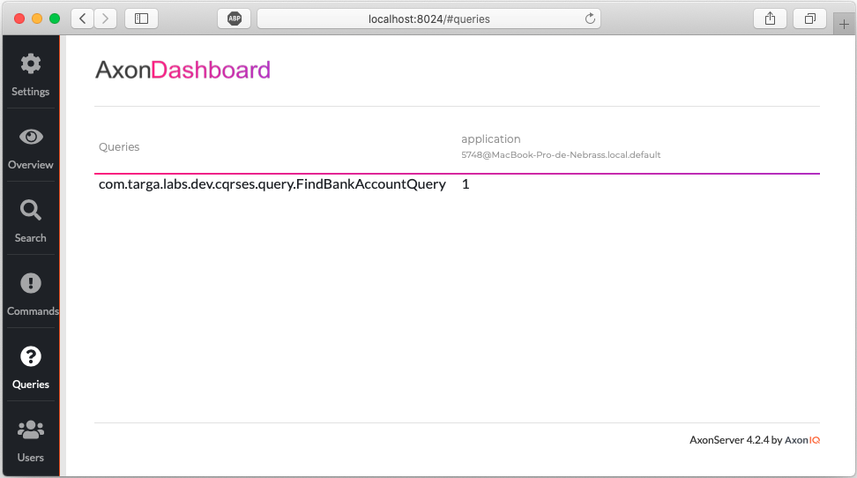

*Axon Server UI – Queries after execution*

You can easily see that the **FindBankAccountQuery** was executed once.

You can see all of the **Events** in the **Search** section. Click directly on **Search button** to **grab all the Events**:

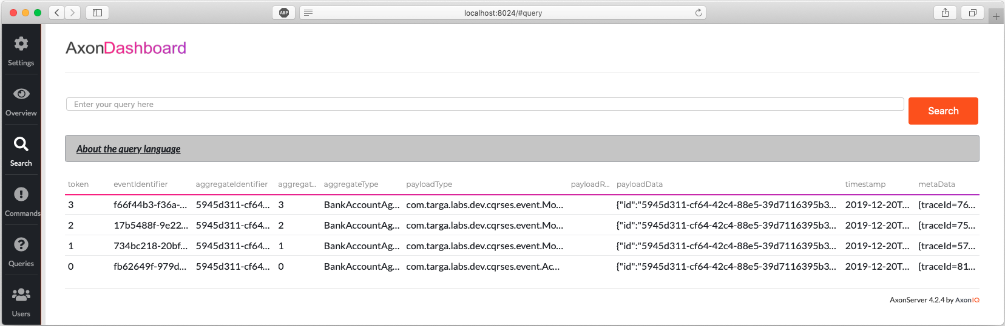

*Axon Server UI – Search section*

If you want to test our **Axon** code **programmatically**, we will start by adding the **Axon Test module** to the pom.xml:

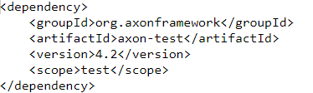

Next, we will create a **BankAccountTest** class:

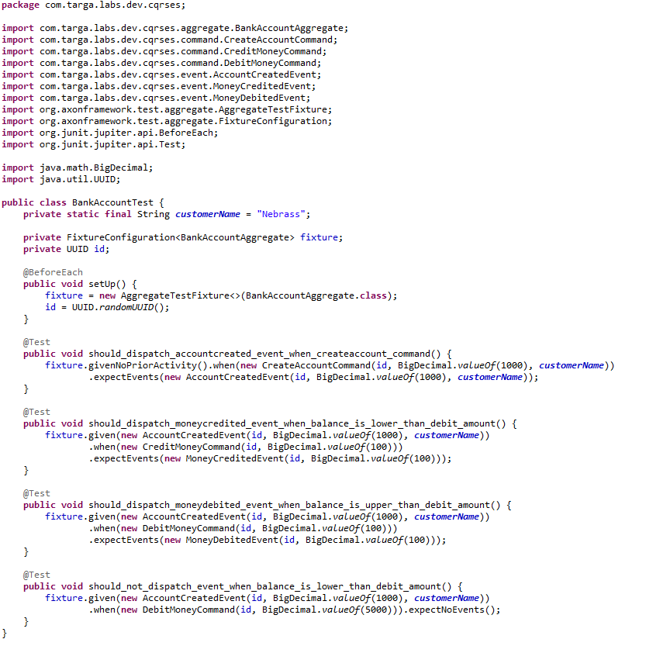

In our **BankAccountTest** class, we are using **FixtureConfiguration** class which we will use to define a test scenario in terms of events and commands:

* Given certain events in the past
* When executing this command
* Expect these events to be published

Our test are designed like:

* In the first test, we are testing an **Account Creation operation**:
  + we are supposing that we don’t have any account created
  + when we will dispatch a **CreateAccountCommand**
  + we are expecting to get the a **AccountCreatedEvent** with the same values
* In the second test, we are testing the **Credit Money operation**:
  + we are supposing that we have an account
  + when we will dispatch a **CreditMoneyCommand** with an amount of 100
  + we are expecting to get the a **MoneyCreditedEvent** with an amount of 100
* In the third test, we are testing the **Debit Money operation**:
  + we are supposing that we have an account
  + when we will dispatch a **DebitMoneyCommand** with an amount of 100
  + we are expecting to get the a **MoneyDebitedEvent** with an amount of 100
* In the third test, we are testing the impossibility to execute **Debit Money operation** when **the requested amount is higher than the account balance**:
  + we are supposing that we have an account
  + when we will dispatch a **DebitMoneyCommand** with an amount of 5000
  + we are expecting to have **NO events that occurred**

The sample code of this tutorial can be found on [Github](https://github.com/nebrass/playing-with-cqrs-and-event-sourcing-in-spring-boot-and-axon).

